**Experimental Analysis of Spark Ignition Performance**

Christopher R. White

MWG: David Bedding, Jorge Godoy, Samuel Hordeski, Kevin Myers, Justin Sandler

Department of Mechanical Engineering

Lafayette College

Easton, PA 18042

**Abstract**

The majority of automobiles operate on the four-stroke intrernal composition (IC) engines that convert chemical energy from gasoline via combustion through a spark igniton (SI) process in order to produce mechanical energy. The increase in pressure via the combustion drives pistons that rotate a crankshaft and output power to the wheels. Due to environmental and economical incentives, automobile engine manufacturers are driven to optimize and rate their products in order to extract the most energy out of the fuel source since IC engines produce useful torque between limited range of rotational speeds. Therfore engine simulations of parasitic loads (brake work) instead of physical testing are utilized to create a model to determine how to optimize or rate an engine. The purpose of this experiment was to determine the optimal ranges to achieve the maximum engine efficiency of a Briggs & Stratton V-Twin OHV engine. Crank shaft angle and pressure witin the cylinder were measured for 3 complete cycles while applying fluid loads via water brake dynometer between minimum and maximum water flow rate interfaced with the crankshaft. It was tested at low, middle, and full throttles at ____,____, and ____. This range of loadings between low end torque and high end torque was used to explore the effect of load on **engine efficiency, condenser efficiency, and condenser effectiveness**. In this experiment, the performance was evaluated based on the torque curves under various loadings while maintaining constant trottle. The results were compared to published data from manufacturer [brigs Stratton data]. **It was observed that the turbine efficiency had a steep positive slope at loading below the 60 bulb loading, where it began to plateau at an effectiveness of approximately 59%. The 60 bulb load is the most optimal loading as it resulted in the highest turbine efficiency of 59.9±2.6% with a cycle thermal efficiency of 1.14±0.57% and condenser effectiveness of 0.17±0.02. The 20 bulb case had the lowest turbine efficiency of 36.7±1.1%, while the 100 bulb loading resulted in a slight dip in efficiency within the plateau region of 58.8±3.9%.**

The Otto cycle operates on the principle of producing work as it flows from a high resivor to cold resivior (check book). They are reciprocating devices that contain pistons that travel back and forth in cylinders in the engine block. **In the four-stroke cycle there are a total of 4 piston movements over 720˚ crankshaft revolutions for each cycle**

**Introduction and Methods**

The U.S. Energy Information Administration displays an unpredictably, yet upwards trend in nominal petroleum price per gallon since 1998 at $1.03 per gallon to a predicted 2016 price of $2.73 per gallon[1]. This is primarially due to the depleting earths resounces and uncertainty of reserves. In the modern world, there are ever increasing concerns about the deleting supply of the earths fossil fuels,which severely impacts the automotive industry. The increase in fuel prices in addition to the uncertainty of available is putting a priority of fuel economy of engines. Multiple studies have reported that there is a link between greenhouse gasses produced by automobile engines and the partial destruction of the atmosphere resulting in global warming. According to the law of conservation of energy, designing an engine of higher efficiency results in both environmental and economic incentives, since more energy is extracted from the fuel. Therefore IC engine manufacturers test the performance of their products by applying paracitic loadings to simulate variable physical loadings. Designing an IC engine depends on the compromise between performance, fuel economy, and emissions. this study will focus on the performance of the engine. In order to analyze a protoype IC engine, the Otto cycle is used to represent the four-stroke cycle as an idealized thermodynamic cycle with no internal irreverabilies. The actual four-stroke engine can be analyzed using thermodynamics assuming ideal properties or air. This results in the Otto cycle. consists a piston that travels in a total of 4 strokes that make up the a single thermodynamic cycle. The two additional processes are the isobaric exhaust of waste heat and combustion, and intake of cool oxygen isobaric ally which are omitted in the simplified analysis. The Otto cycle is illustrated in Figure 1 and comprises of four strokes are called intake, compression, power, and exhaust that can be analyzed using the steady-flow energy equation, expressed as

${(q}_{in}-q_{out})-{(w}_{in}-w_{out})= h_{e}-h_{i}$ (kJ/kg) ⑴

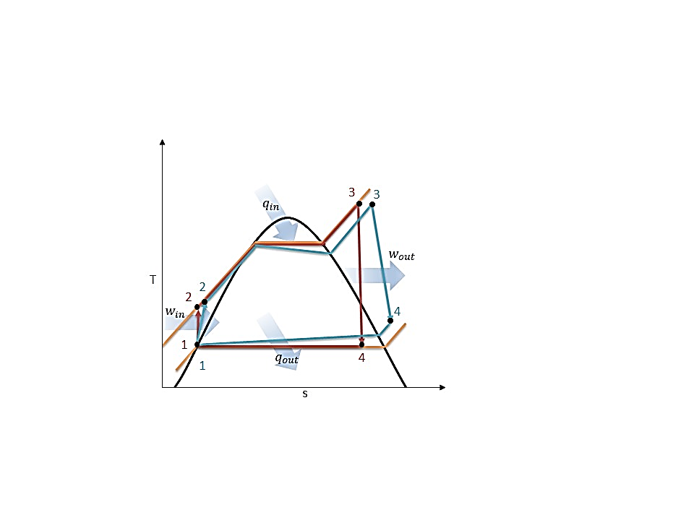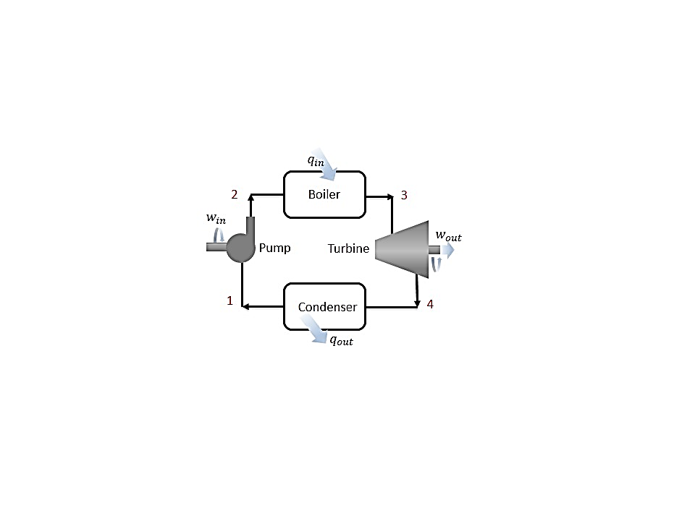where $q$ is heat transfer and $w$ is the work, and $h$ is the enthalpy at the exit and inlet of the control volume. These components can be analyzed under the assumption that they are steady-flow devices that have minimal changes in kinetic and potential energy relative to the work and negligible heat transfer. As well as standard air assumptions

**Figure 1: (a) Schematic, and (b) Temperature-Entropy Diagram for Ideal (red) and Actual (blue) Rankine Cycle [1] replicated by White C.**

This can be represented using the Otto cycle which begins with process 6-1 as a fuel-air mixure is drawn into the cylinder isobarically with the piston initially at top dead center (TDC) moves to bottom dead center (BDC)resulting in an increase in the volume of the engine cylinder. The mixture is then isentrropincally compressed in process 1-2 as the piston travels from BDC to TDC resulting in an increase in the pressure. Heat is transferred isochorically to the mixture in process 2-3 via spark from sprak plug. Work is isentropic generated through the power stroke in process 3-4 as tehe piston is driven from TDC to BDC. Heat is rejected isochorically from the engine in process 4-5 at BDC. The mass of spent fuel is expelled from the engine to the enviroment in process 5-6 throiugh the exaust stroke. The cycle then repets repeats back to intake process 6-1.

In the actual **four-stroke spark-ignition engine**, the rotations of the output shaft is indirectly controlled through the throttle, it is the device that regulates the fuel-air mixture entering the engine via constriction or obstruction during each cycle.

In the current study, engine efficiency was experimentally determined for low, middle, and full throttles at ____,____, and ____. The actual cycle was compared to the Otto cycle and published data in order to validate the experimetnt.

The experiments were performed on a Briggs & Stratton V-Twin OHV engine with a **dynometer**. **Temperature, pressure, and mass flow rate** were measured at specific points in the cycle. The experimental schematic and locations of the instrumentation are illustrated in Figure 2.

3 experiments were performed: idle throttle (), half throttle (steady state rpm?, doesn’t reach steady state through), full throddle. The throttle trials were held constant for each trial and loading were applied to the output shaft via water brake dynamometer. ________ data was aquriered for each of the ____ loadings. The water mass flow rate was controlled via hand valve which was twisted for a total of ____ approimately equal turns for each loading.

Each component of the Rankine cycle can be analyzed using Eq. (1), expressed as

$w_{pump,in}= h_{2}- h_{1}$ (kJ/kg) ⑵

$q_{in}= h_{3}-h_{2}$ (kJ/kg) ⑶

$w_{turb,out}= h_{3}- h_{4}$ (kJ/kg) ⑷

$q_{out}= h_{4}-h_{1}$ (kJ/kg) ⑸

assuming no heat transfer during the work processes and no work during the heat transfer processes. While the ideal Rankine cycle is useful for understanding the thermodynamics behind the process, the actual steam turbine cycle has deviates from the ideal due to irreversabilities in each component as illustrated in the T-s diagram in Figure 1. Irreversabilities are present within any mechanical device and results in a decrease in the performance and can be accessed by determining the effectiveness, which is the ratio of the power in to the power out. In the experimental set up, there are irreverabilities within the steam turbine and the generator which results in efficiencies for both devices. The mechanical efficiency of the turbine is the ratio between the output of the shaft and the power of the working fluid. The electrical efficiency of the generator is the ratio between the electrical power output and the work of the shaft, based on a calibration curve for the efficiency in respect to percentage of full loading[3]. The efficiencies of the turbine and the generator are expressed as

$η_{T}=\frac{w_{s}}{w_{f}}$ ⑹

$η_{G}=\frac{I×V}{w_{s}}$ ⑺

where $η_{T}$ and $η_{G}$ are the turbine and generator efficiencies, $w_{s}$ and $w_{f}$ are the actual work of the shaft and working fluid, $I$ and $V$ are the current and voltage difference from the generator respectively. Since the power of the shaft is unknown, it can be disregarded by combining Eqs. (5 & 6) and therefore turbine efficiency is defined as

$η_{T}=\frac{I×V}{{w_{f}×η}_{G}}$ ⑻

Based conservation of energy, the cycle thermal performance of the entire cycle is characterized by the thermal efficiency, the ratio between the net power done and the heat supplied by the boiler, namely,

$η_{th}=\frac{w_{net}}{q_{in}}=\frac{w_{turb,out}-w_{pump}}{q_{in}}$ ⑼

Condenser effectiveness is a function of the NTU, heat capacity rate ratio, and the heat exchanger flow arrangement and is defined as the ratio of actual heat transfer rate for a heat exchanger to the maximum possible heat transfer rate and can be written as

$ε=\frac{q}{q_{max}}$ ⑽

where $ε$ is the condenser effectiveness, $q$ is the actual heat transfer rate, and $q_{max}$ is the maximum heat transfer rate.

**Figure 2: Experimental Steam Turbine Schematic with Instrumentation Locations: Type-T Thermocouples, Ashcroft Type 1009SW Pressure Gauges, and 1” Cooling Water Flow meter [White C.]**

**Results and Discussion**

The following experiment was considered: Resistive load cases of 20, 60, and 100 light bulbs at a steam turbine output shaft rotational speed of 3658 RPM at no load.

The steam turbine system was prepared according to the startup procedure in the Operating Instructions at a laboratory temperature of 26.4˚C and barometric pressure of 99.9 kPa [3]. The steam turbine inlet valve was used to slowly increase the mass flow rate of the superheated steam in order to warm up the turbine blades to prevent damage until a rotational speed of 3658 RPM was achieved. Loading was incremented in sets of 10 bulbs to achieve the loading cases of 20, 60, and 100 via the generator in order to observe the variation in turbine efficiency between low to high loadings. At the locations illustrated in Figure 2, temperature, pressure, and mass flow rate were measured 3 times for each load case to confirm that the system had reached steady state, defined by minimal changes between measurements sets. Steam condensate flow rate was measured for each case with a weigh tank and stopwatch, resulting in flow rates of 50.3, 71.1, and 109.6 g/s respectively. The work and heat transfer were determined using Eqs. (2-5) and T-s diagrams for each load case were generated using Mat lab and XSteam for the ideal and actual steam turbine cycles in Figures 3-6. The turbine efficiencies for the 20, 60, and 100 load cases were 36.7±1.1%, 59.9±2.6%, and 58.8±3.9% respectively. In addition, the cycle efficiencies and condenser effectiveness were determined using Eqs. (9 & 10) and are displayed in Table 1.

Based on the T-s curves for the ideal Rankine cycle and the actual steam plant cycle displayed in Figures 3-5, it is evident that there are some deviations between the two cycles. This is attributed to the additional components in the actual cycle as well as the irreverabilities within the steam turbine. The experimental set up was not a true Rankine cycle because it was an open loop system that did not direct the condensed steam to the feed water pump and boiler. Therefore in order to model the actual cycle, the pump and boiler processes were predicted based on ideal cycle assumptions. It was assumed that the feed water pump was an isentropic device and there was no work applied or pressure losses during the boiling process. Steam is delivered to the system from the boiler at the College steam plant where it passes through a separator, which ensures that the steam entering the super heater is a saturated vapor through a centrifugal process. The steam enters the super heater where the temperature of the steam increases until the steam becomes a superheated vapor between stages 1 and 2. After the superheater, the steam enters the turbine inlet valve between stages 2 and 3 where there is a decrease in temperature due to friction and heat loss to the environment. Between stages 3 and 4 the superheated steam flows through the inlet valve which acts as a throttling device and results in an isenthalpic pressure drop. The most significant difference between the cycles is visible in the steam turbine between points 4 and 5. This is a result of the irreversabilities within the turbine as the steam flow results in friction in the interior of the turbine resulting in heat generation that is lost to the surroundings. This is most evident as loading increases because mass flow rises and the irreverabilities within the turbine are magnified, since the mass flow of steam must increase to maintain the turbine output shaft at approximately 3600 RPM. The more bulk fluid motion flow through the turbine results in more friction occurring between components. In addition as the mass flow rate increased, the pressure drop across the turbine inlet valve decreased. At the 100 bulb load case, the pressure of the condenser decreased due to the high flow rate exiting the turbine. Unlike the Rankine cycle, where the steam condenses to a mixture within the turbine, the actual cycle ensures that the steam leaves the turbine as a superheated vapor to prevent any damage to the turbine from condensation. Minor irreverabilities are present throughout the actual cycle resulting from piping losses within the boiler at stages 11 and 1, as well as within the condenser between stages 7 and 8. The turbine efficiency and thermal cycle efficiency were evaluated and compared based on the loadings applied to the turbine output shaft.

**Figure 3: 20 Bulb Loading Temperature-Entropy Diagram for the Ideal Rankine Cycle (purple) and Actual Steam Turbine Cycle (blue)**

**Figure 5: 100 Bulb Loading Temperature-Entropy Diagram for the Ideal Rankine Cycle (purple) and Actual Steam Turbine Cycle (blue)**

**Figure 4: 60 Bulb Loading Temperature-Entropy Diagram for the Ideal Rankine Cycle (purple) and Actual Steam Turbine Cycle (blue)**

It was observed that turbine efficiency increased rapidly until the 60 bulb load, after which the efficiency plateaued and began to decrease slightly at higher loads, which is consistent with the calibration data for the 5K VA generator. Based on Table 1, turbine efficiency increased rapidly between the 20 and 60 bulb loadings. Beyond the 60 bulb loading, efficiency remained at a plateau region where it steadily decreased as displayed by the 100 load case. Cycle thermal efficiency is limited only by the high heat of vaporization of the working fluid and increased regardless of the loading. This is because cycle thermal efficiency is only dependent on the ratio between the power output and the heat transferred into the system by the boiler, which are unaffected by the turbine output shaft loading. The power is being generated based on the thermal energy of the fluid and does not take into account the actual turbine blades upon which entropy is generated resulting in a lower effectiveness. The efficiency of the turbine is the result of irreversabilities present within the turbine due to the interaction between the working fluid and inside of the turbine resulting in heat generation from friction. The uncertainties for the turbine efficiency were below 4%, however they were significantly high for the cycle thermal efficiency at approximately 0.6%. This is attributed to the prediction of the boiler heat transfer which was estimated based on the ideal Rankine cycle. As a result, the estimation did not provide an accurate approximation of the cycle thermal efficiency.

The condenser effectiveness was primarily influenced by the mass flow rate of the steam condensate. The steam condensate increased for higher loadings and therefore due to the high flow rates, the rate of heat transfer in the condenser increased between cooling water and the condensing steam. This resulted in an increase in the condenser effectiveness of the heat exchanger as displayed in Table 1. The uncertainties for each of the loading cases were below 0.0205 for the condenser effectiveness and therefore were insignificant.

**Table 1: Actual Steam Turbine Efficiency, Cycle Thermal Efficiency, and Condenser Effectiveness for Each Load**

|  |  |  |  |  |  |  |  |  |  |
| --- | --- | --- | --- | --- | --- | --- | --- | --- | --- |
| Load (Bulbs) | Turbine Efficiency (%) | | | Cycle Thermal Efficiency (%) | | | Condenser Effectiveness | | |
| 20 | 36.9 | ± | 1.1 | 1.14 | ± | 0.57 | 0.17 | ± | 0.0200 |
| 60 | 59.9 | ± | 2.6 | 2.62 | ± | 0.43 | 0.24 | ± | 0.0203 |
| 100 | 58.8 | ± | 3.9 | 3.88 | ± | 0.31 | 0.31 | ± | 0.0202 |

**Conclusions**

The purpose of this experiment was characterize the performance of the steam turbine by determining the effect of variable loadings on the steam turbine cycle. Though the conservation of energy and the generator efficiency correlation, the turbine efficiency, cycle efficiency, and condenser effectiveness were determined. The uncertainties for the turbine efficiency were below 4%, significantly high for the thermal efficiency around 0.6% and below 0.0205 for the condenser effectiveness. While cycle efficiency was low with a high uncertainty, this is attributed to the prediction of the boiler heat transfer. Based on the experiments it was determined that the 60 bulb load was the optimal loading, since it achieved a thermal turbine efficiency of 59.9±2.6%. This was the loading at which the efficiency curve began to plateau, whereas for the 100 bulb loading, the turbine efficiency began to decrease. Therefore the steam turbine operates at maximum efficiency at a loading of 60 bulbs.

**References**

1. U.S. Energy Information Administration - EIA - Independent Statistics and Analysis. (n.d.). Retrieved March 26, 2015, from http://www.eia.gov/forecasts/steo/realprices/
2. Ҫengel, T.A. and Boles, M.A. (2002) *Thermodynamics: An Engineering Approach,* McGraw Hill, 4th Edition.
3. Rossmann, T., Sabatino, D. & Utter B. (2015). *ME 475: Spark Ignition Laboratory Description*. Easton, PA: Lafayette College.
4. Moran, M. & Shapiro, H. (2004) Fundamentals of Engineering Thermodynamics, Wiley, 5th Edition.
5. Pulkrabek, W.W. (1997) Engineering Fundamentals of the Internal Combustion Engine, Prentice-Hall.

The air-standard assumptions are applicable. 2 Kinetic and

potential energy changes are negligible. 3 The variation of specific heats

with temperature is to be accounted for.

At idle, the thermal efficiency is zero, since no usable work is being drawn from the engine. At low speeds, gasoline engines suffer efficiency losses at small throttle openings from

. At high speeds, efficiency in both types of engine is reduced by pumping and mechanical frictional losses, and the shorter period within which combustion has to take place. Engine efficiency peaks in most applications at around 75% of rated engine power, which is also the range of greatest engine torque (e.g. in most modern passenger automobile engines with a [redline](http://en.wikipedia.org/wiki/Redline) of about 6,000 RPM, maximum torque is obtained at about 4,500 [RPM](http://en.wikipedia.org/wiki/RPM), and maximum engine power is obtained at about 6,000 RPM). At all other combinations of engine speed and torque, the thermal efficiency is less than this maximum.

A major goal in the

design of a modern automobile engine is to *flatten* the torque-versus-speed curve as

shown in Fig. 2-11, and to have high torque at both high and low speed. CI engines

generally have greater torque than SI engines. Large engines often have very high

torque values with MBT at relatively low speed.

**The spark ignition (SI) engine is a type of engine that utilizes a spark plug to ititilaze combustion process to drive the cyhcle. It delivers a high voltage electrical discharge between tow electrodes in order to ignite the fuel-air mixture in the cylinder.**

Power is defined as the rate of work of the engine.

489 – standard air assumptions

491 – otto cyfcle

95 - PDF part trottle

lowest position (BDC)

highest position (TDC),

actual cycle and ideal otto slightly different

graphs plotted over 720 degree cycle

net work is the output of engine with all components area b in hadn out

gross work- is the output of the engine with tfin and exaust system removed area a in hadn out

http://gopowersystems.com/index.php?option=com_content&task=view&id=51&Itemid=60

we don’t have the sencor calibration so evaluated variation based on variation in rpm and torque measurements using stdev and studnets t at 95% conf.

In the actual four-stroke spark-ignition engine, **Process 6-1** ..During this motion, a mixture of fuel and air is injected into the cylinder through the intake port.

During compression, both the intake and exuast valves are sealed andadiabatic compressussion.

… isochoric processs followd by adiabatic expansion. states 2-3 constant volume heat transfer to working gas from external source while piston is top dead center. states 3-4 is an adiabatic expansion (power stroke)

isochoric and isobaric compression. and.states 4-1 constant volume while heat is rejected from air. and processes 1-0 is the exhaust of the air to the atmosphere at constant pressure.

when the throttle is wide open, the engine intake is approximately at ambient atmospheric pressure.

when the throttle is partially closed, a manifold vacuum develops due to the intake dropping below ambient pressure.

This performance of this engine was evaluated by measuring the machine torque

the power is measured by the torque multiplied by the rotational speed of the

output shaft (crankshaft)

Many of the irreverabilities associated with the IC engines are due to the friction and pumping of the fuel-air mixture, resulting in heat transfer and entropy generation. This leaves modern engines with an efficiencay of aproxcimatky

thermodynamics shows that the higher the engine’s compression ratio, the higher its efficiency. however the higher the compression ratios, the more damage can results on the engine ()

https://kb.osu.edu/dspace/bitstream/handle/1811/24538/Meyer_Jason_Honors_Undergraduate_Thesis.pdf;jsessionid=AC650AE2D8972C58C817F03F4D337109?sequence=1

there are mechanical losses in the throttling which reduces the engines efficiency